

**Data & Analytics**

**Homework #5**

March 2022



Data 228 - Big Data Technologies and Applications

Department of Applied Data Science

San Jose State University

***Faiza Ayoun (015960139)***

***Harsimran Kaur (016003468)***

***Pooja Malage (015294760)***

***Saranya Pandiaraj (015304497)***

# Table of Contents

**Table of Contents** **2**

**Step 1: Set up Prerequisites** **4**

Setting up EMR 4

Creating an s3 Bucket 5

Uploading health_violations.py and food_establishment_data.csv to s3 bucket 5

**Step 2: Launch The Cluster** **7**

My Account id 8

**Step 3: Allow SSH access** **9**

**Step 4: Run a hive script to process data** **10**

**Step 5: Clean up your Amazon EMR resources** **13**

Terminating the Cluster 13

Deleting S3 resources 13

References: **15**

*This assignment is designed to walk you through the process of creating a sample Amazon EMR cluster using Quick Create options in the AWS Management Console. After you create the cluster, you submit a Hive script as a step to process sample data stored in Amazon Simple Storage Service (Amazon S3)*

**Follow the steps and submit screenshots / report of your progress.**

[**https://docs.aws.amazon.com/emr/latest/ManagementGuide/emr-gs.html**](https://docs.aws.amazon.com/emr/latest/ManagementGuide/emr-gs.html)



# Step 1: Set up Prerequisites

## Setting up EMR

Create Key PA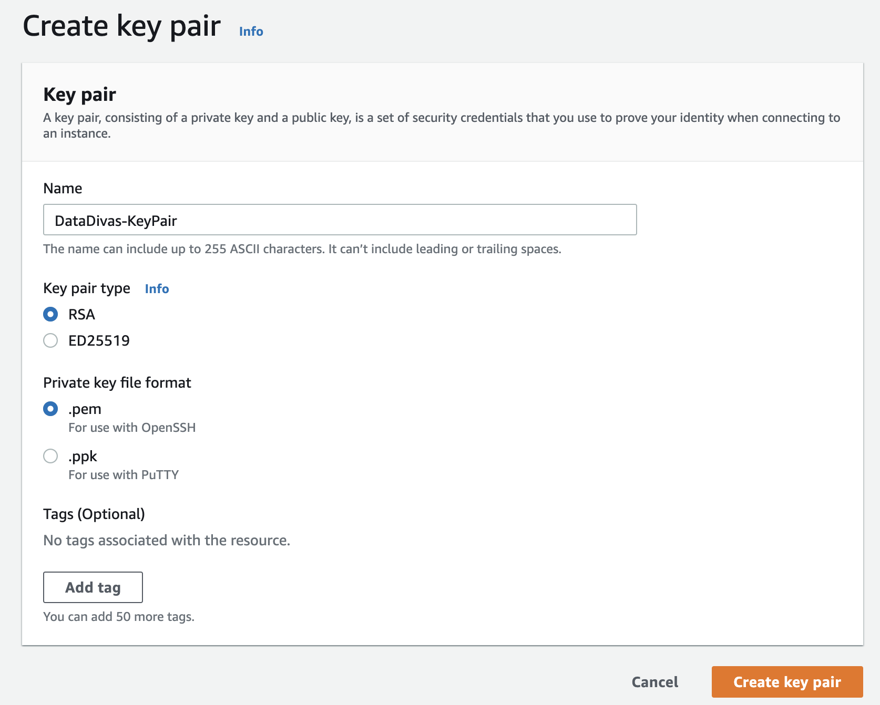

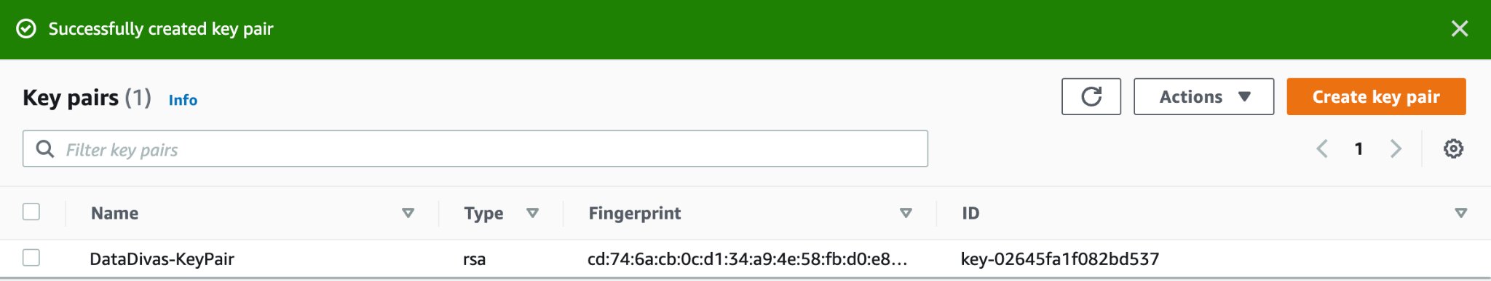

## Creating an s3 Bucket

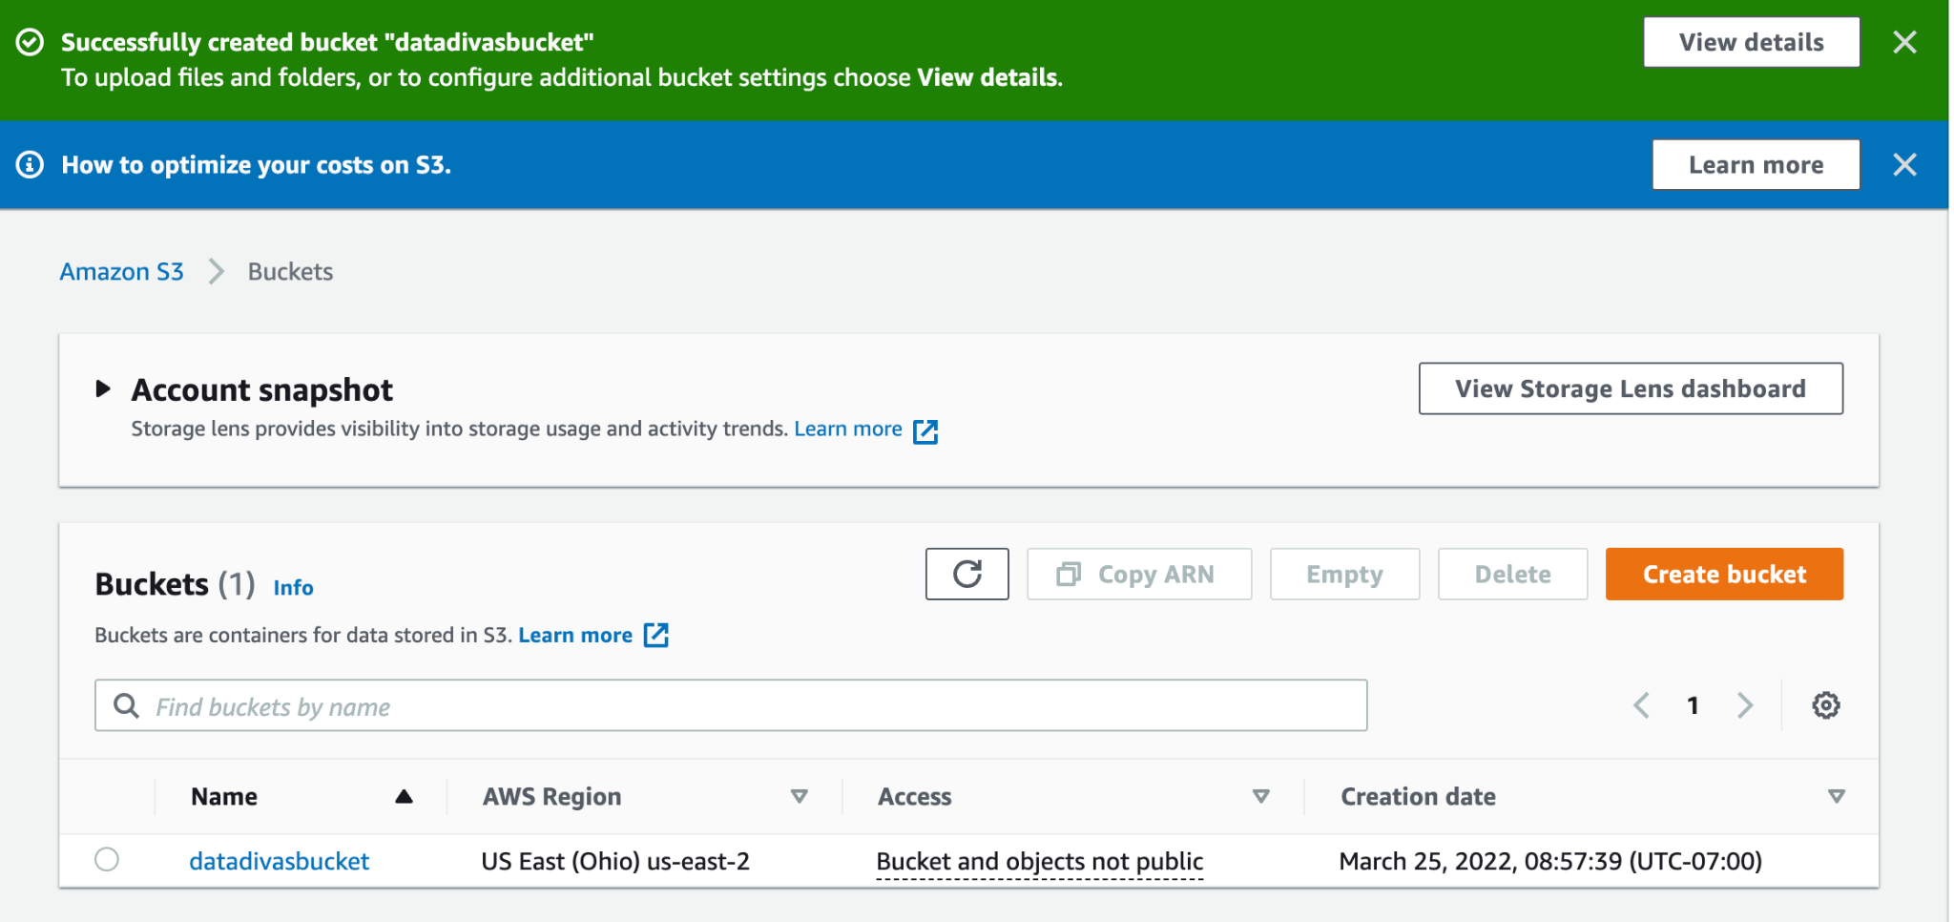

## Uploading health_violations.py and food_establishment_data.csv to s3 bucket

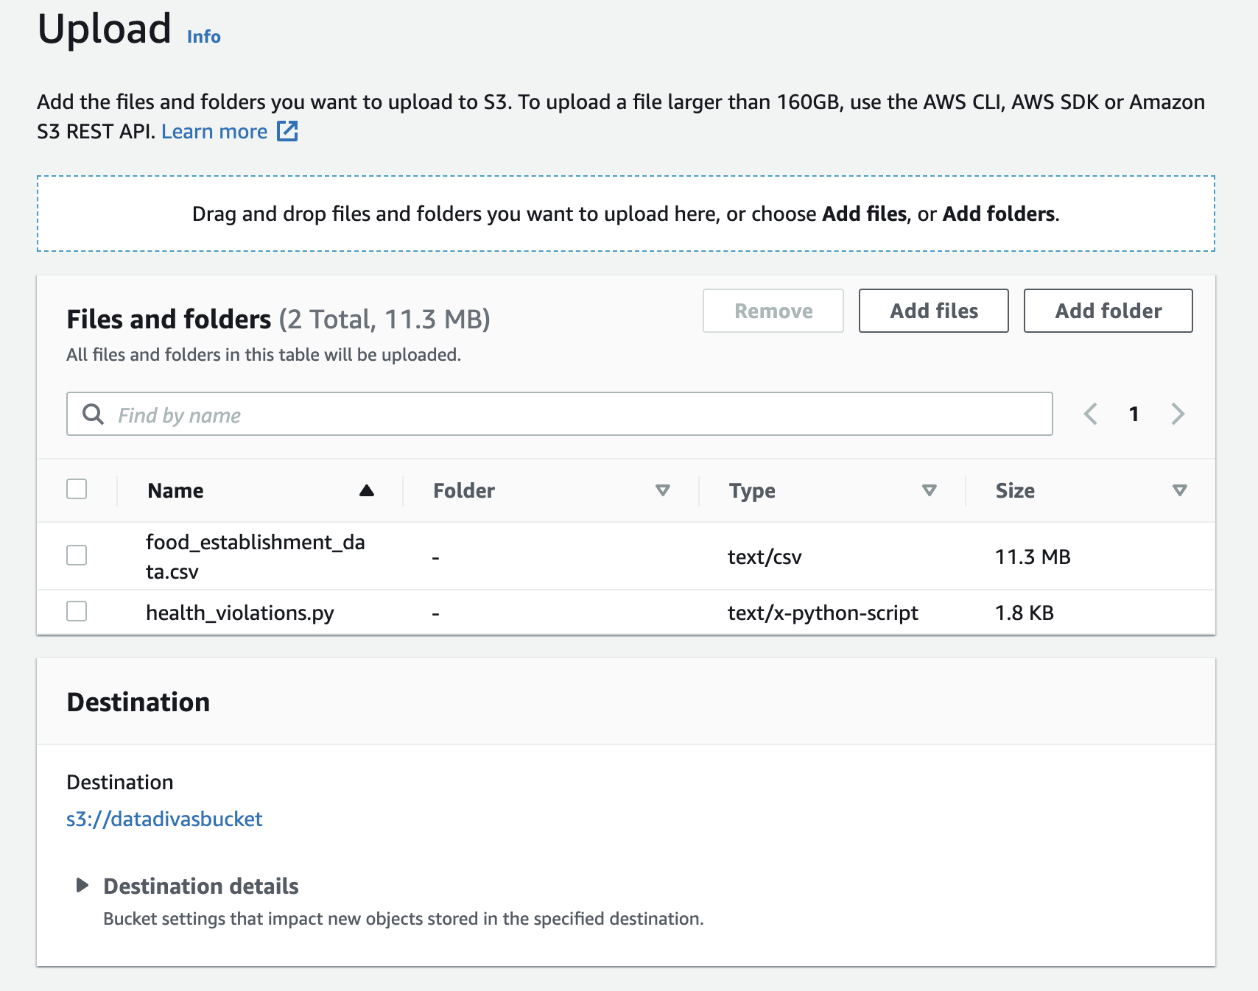

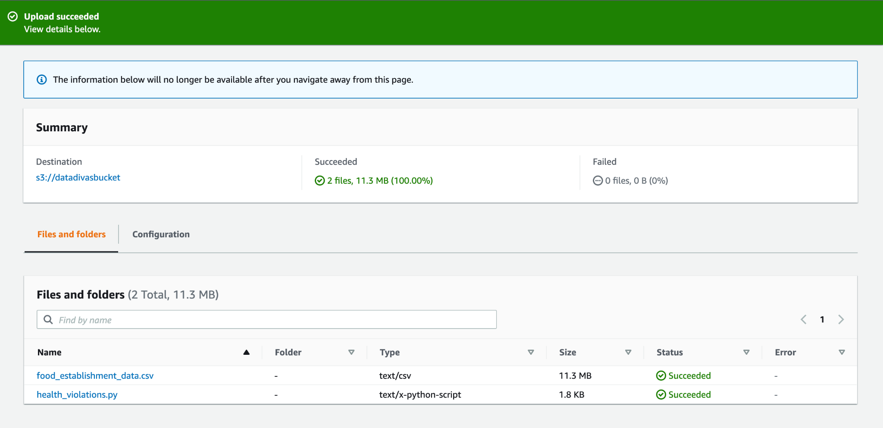

# Step 2: Launch The Cluster

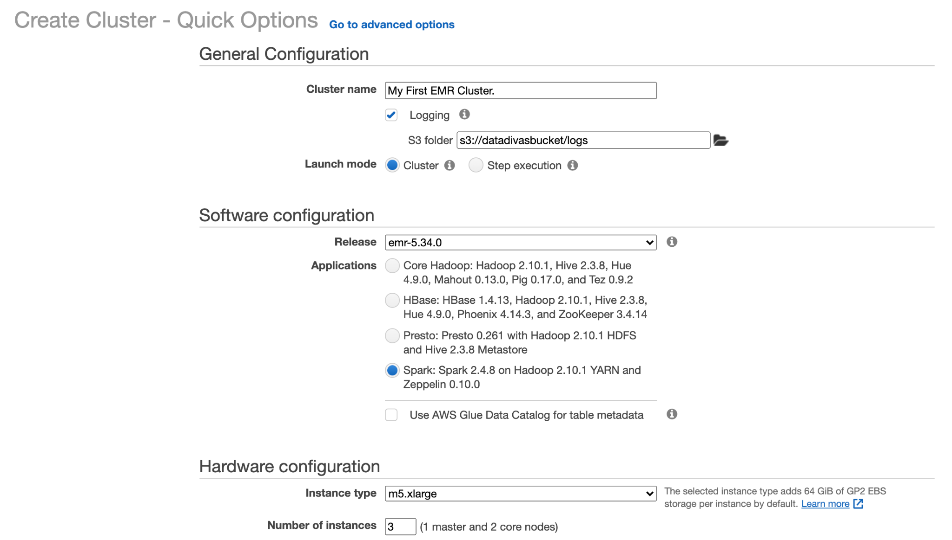

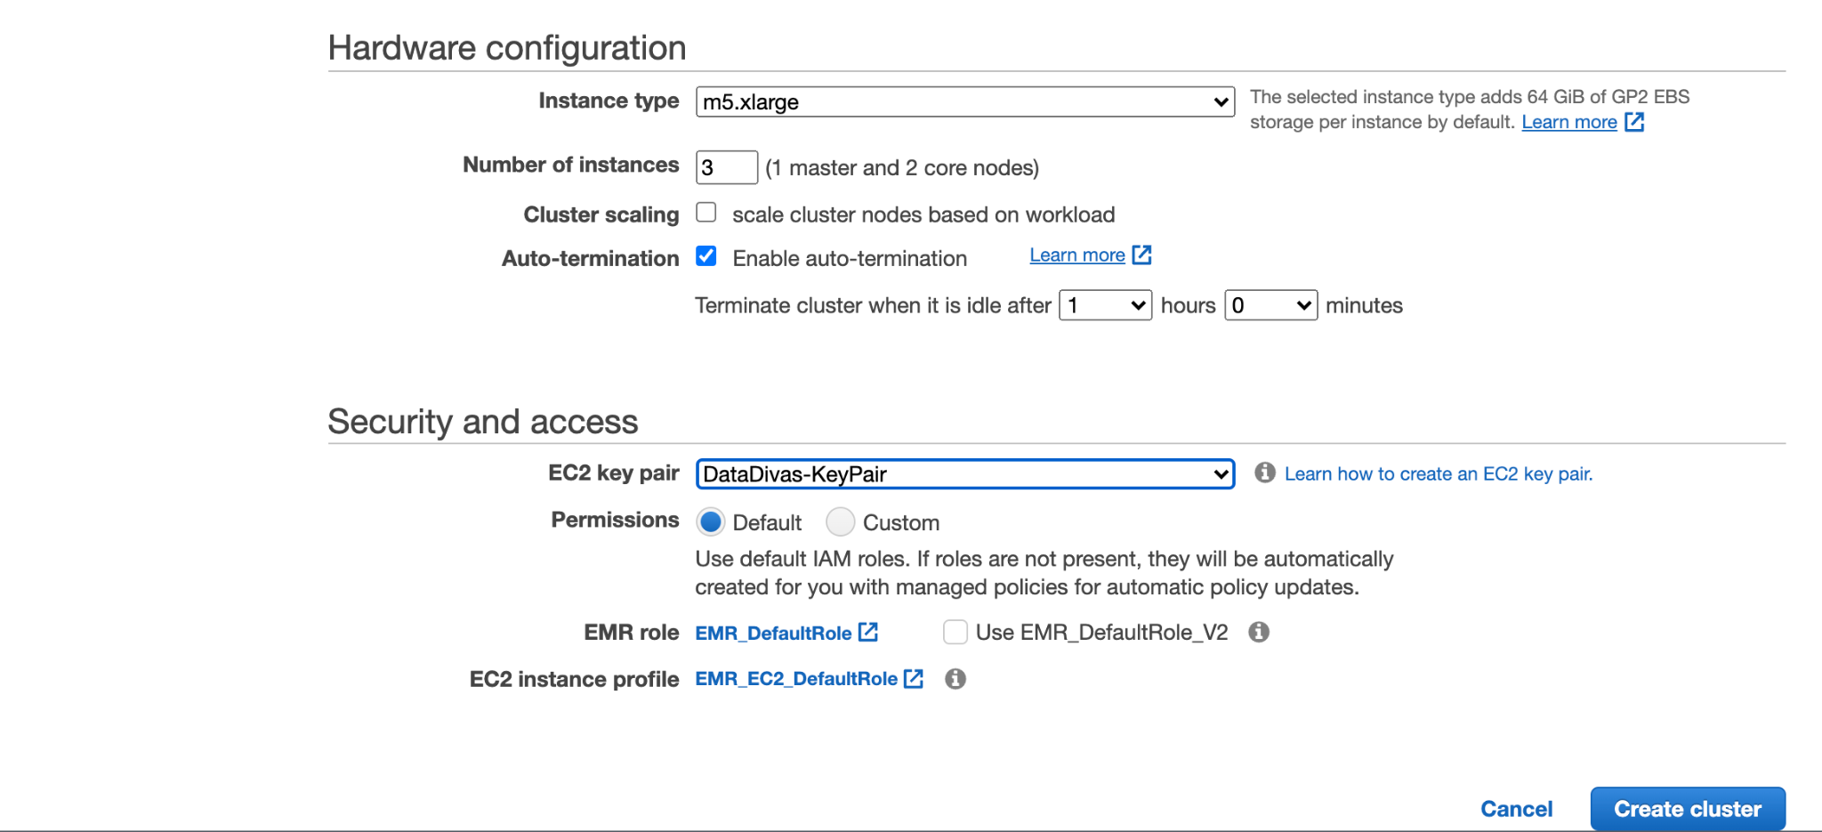

## My Account id

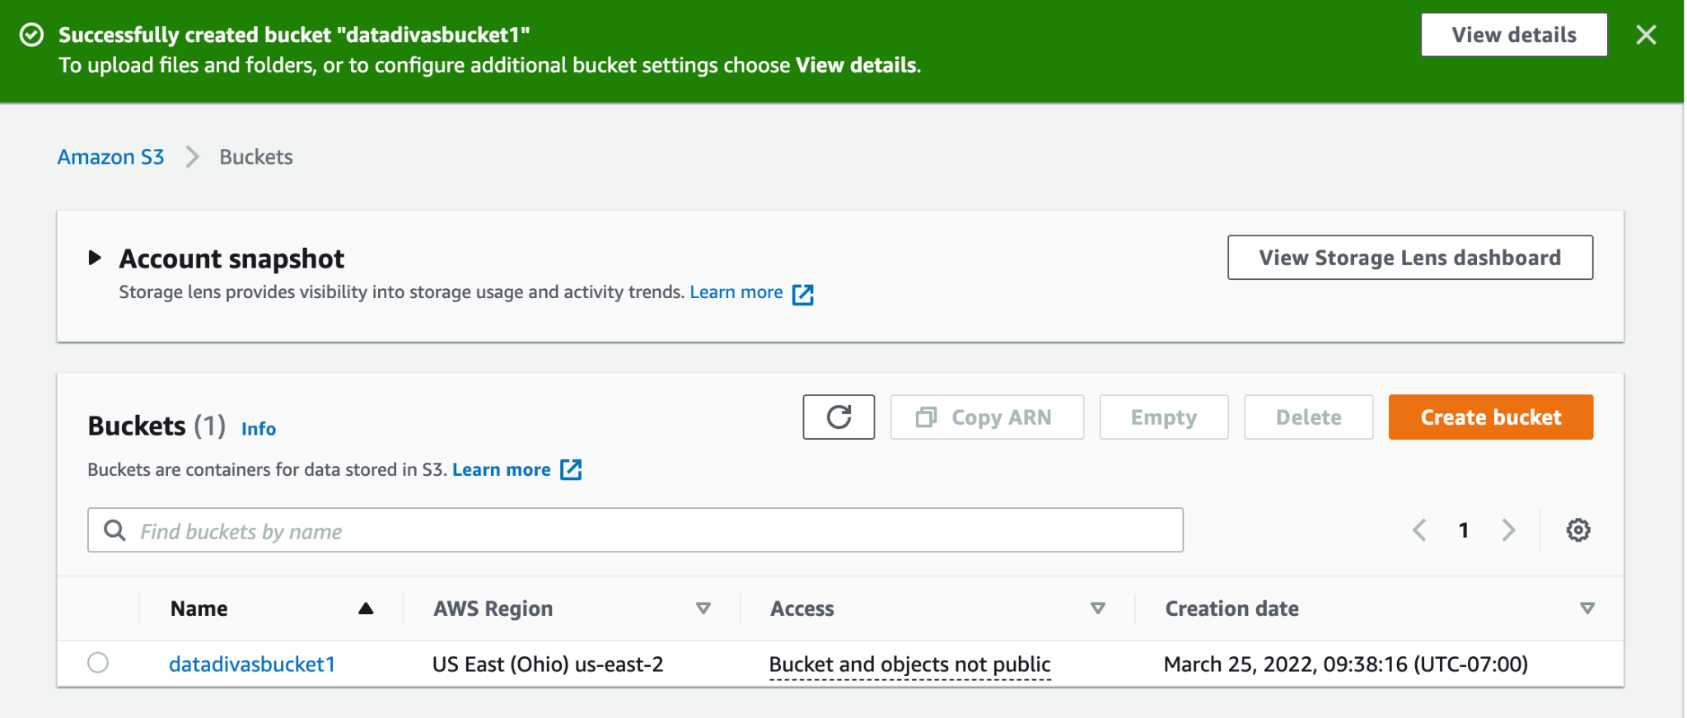

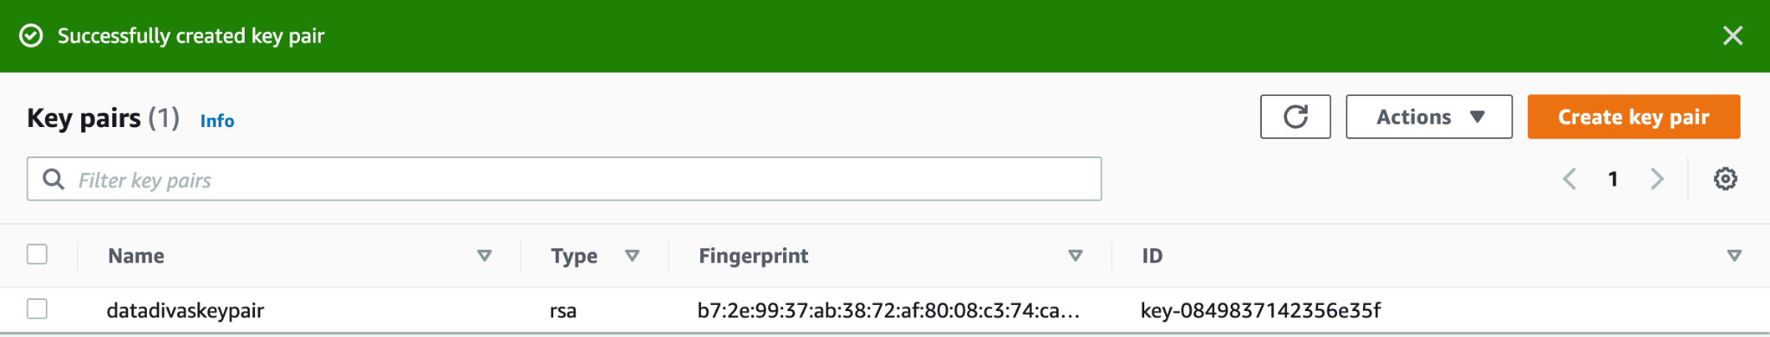

# Step 3: Allow SSH access

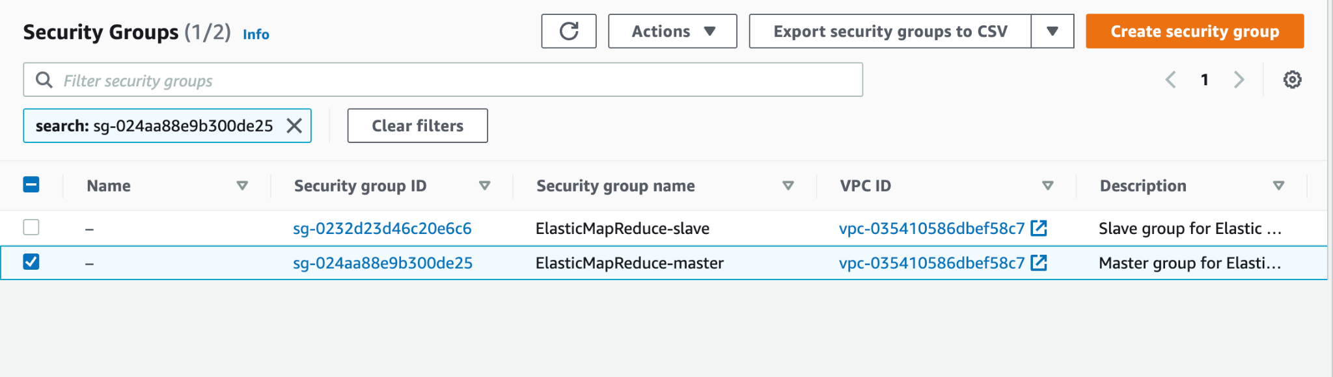

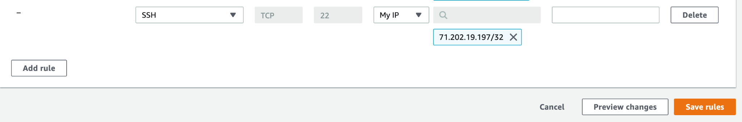



# Step 4: Ru[n a hive script to process data](https://docs.aws.amazon.com/emr/latest/ManagementGuide/emr-gs-process-sample-data.html)

# Step 5: Clean up your Amazon EMR resources

## Terminating the Cluster

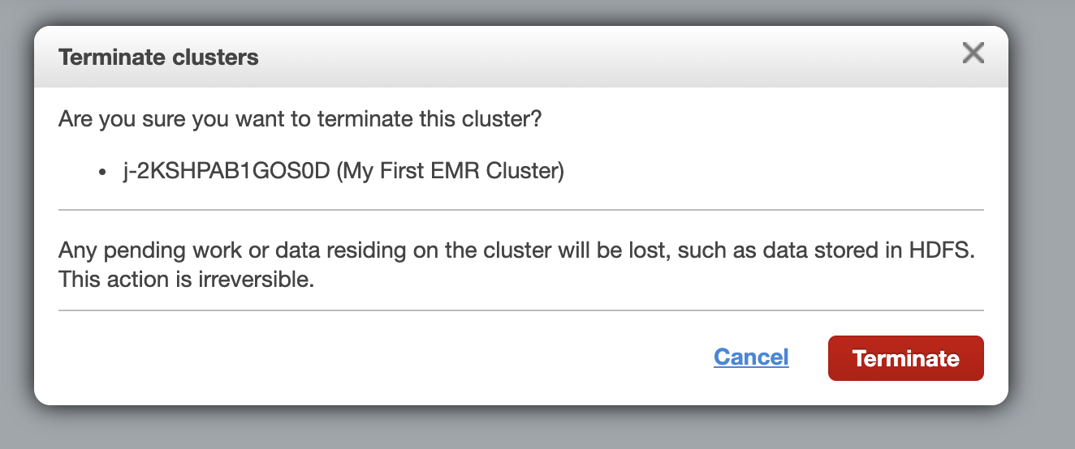

## Deleting S3 resources

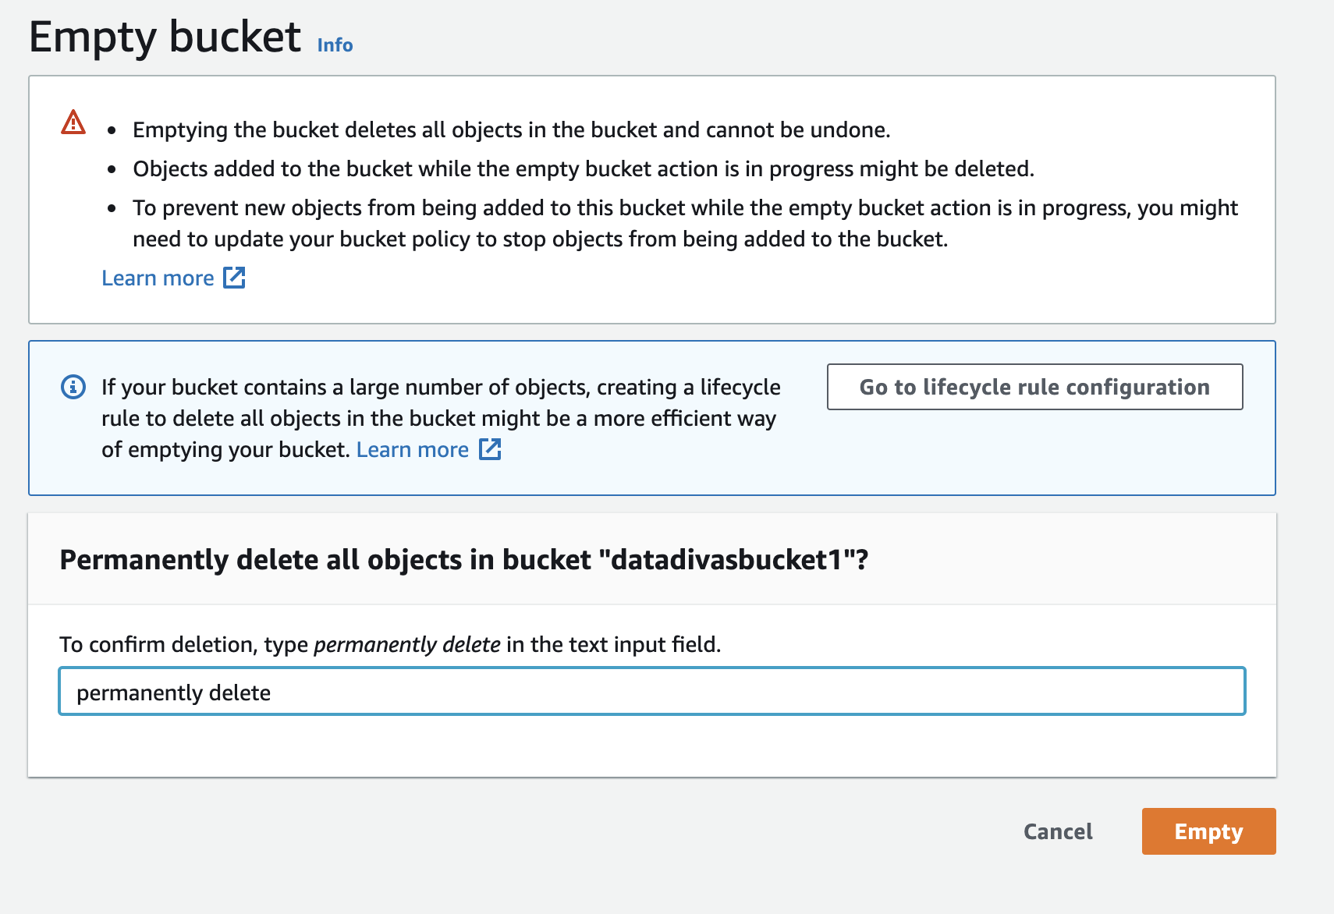



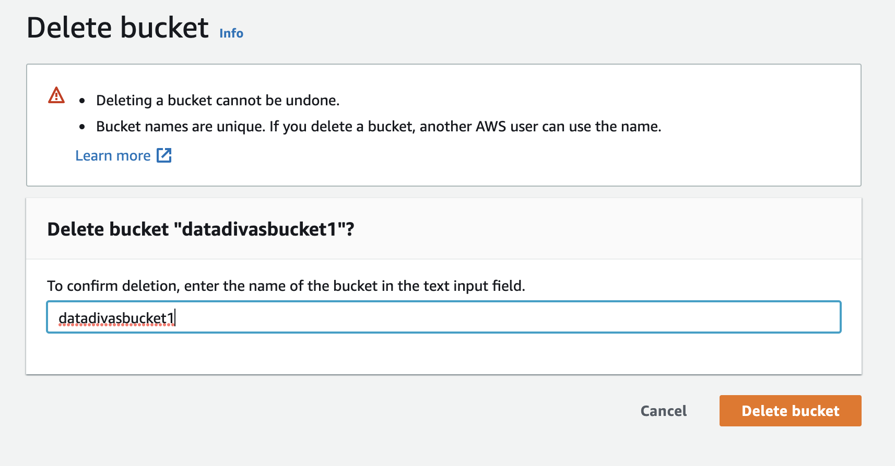

# References:

* (2022). Retrieved 2 April 2022, from https://docs.aws.amazon.com/emr/latest/ManagementGuide/emr-gs.html.